Exercises about OS installations

**To solve the exercises, create a document with screenshots including the settings for each part.**

1. Create an empty virtual machine and configure the following settings:
   * For Windows 10 (64 bits, or 32 if you do not have enough RAM in your physical computer).
   * 2GB of RAM memory.
   * Boot order (CD and hard drive).
   * Two hard drives: one with 50 GB for the operating system and another one with 30 GB empty. Select the type of disk that can dynamically increase.

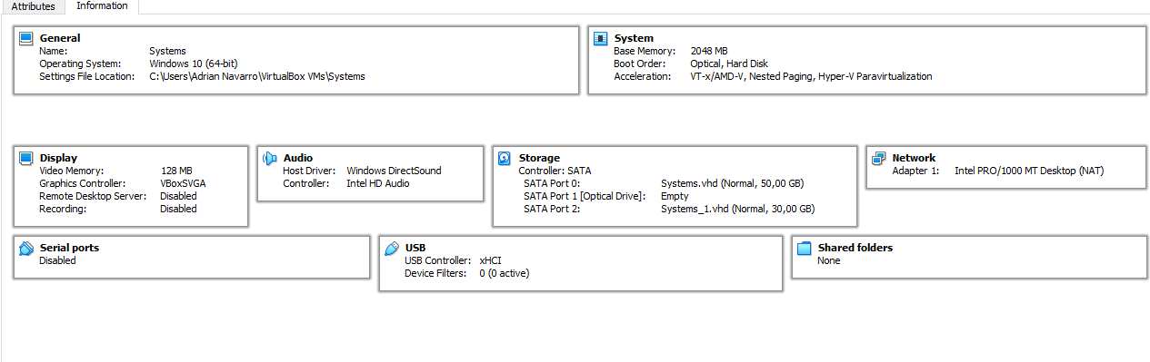

1. Install Windows 10 in the virtual machine from exercise 1. You must add the following settings:
   * USB 3.0 support.

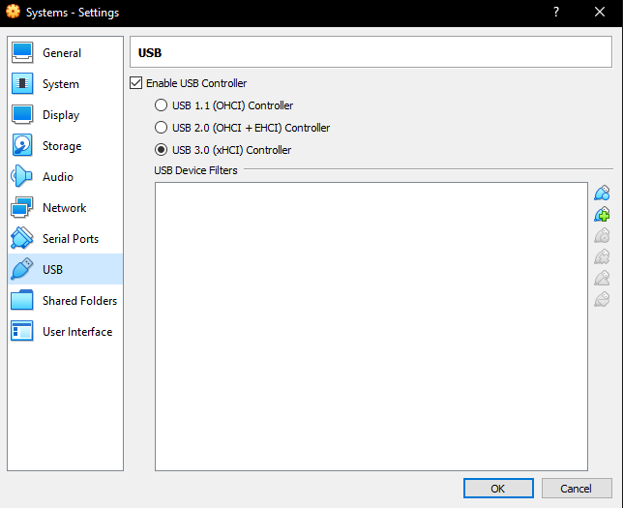

* + Shared folders.

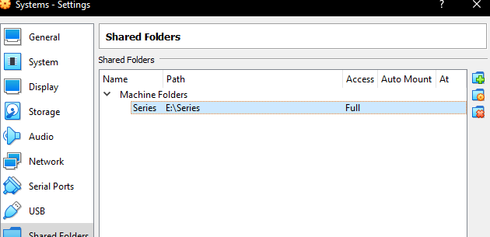

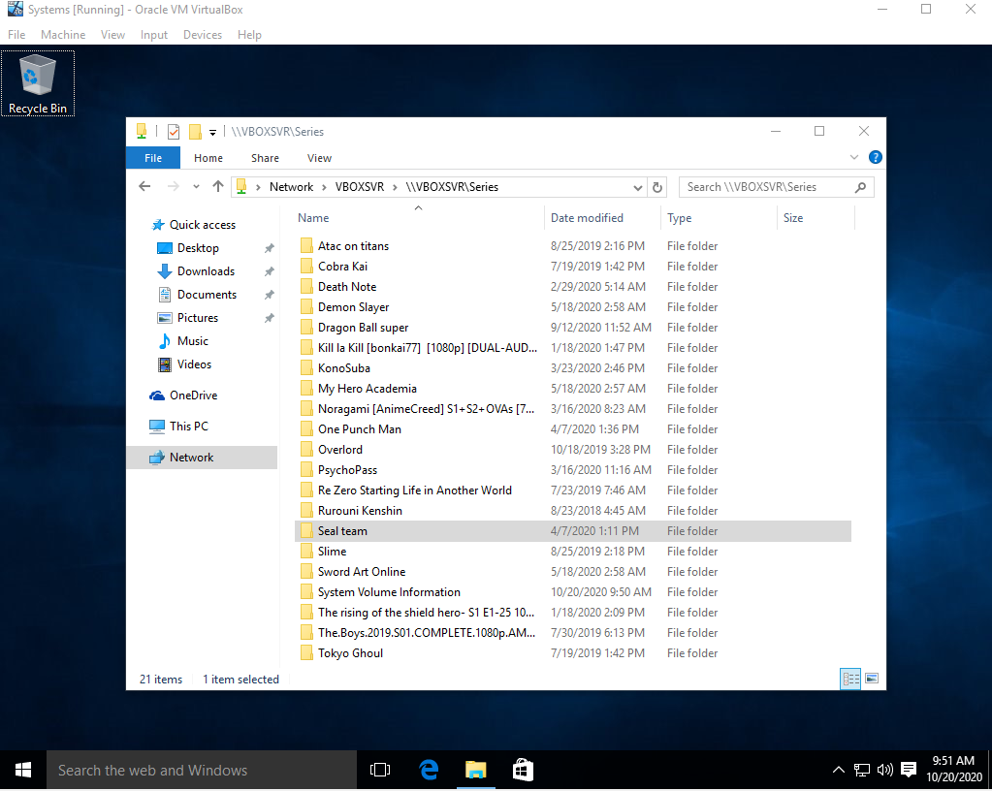

* + Internet connection including access to the rest of computers of the network.

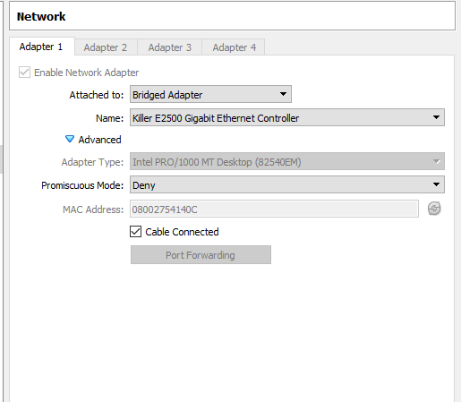

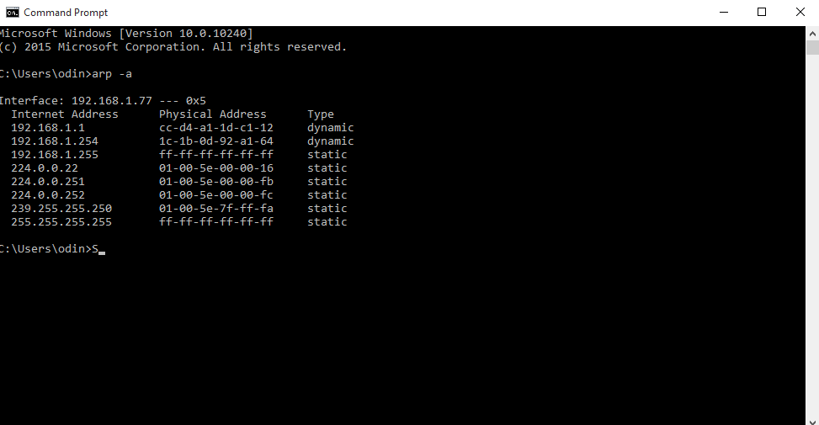

* + You will be able to copy and paste from the host to the guest and vice versa.

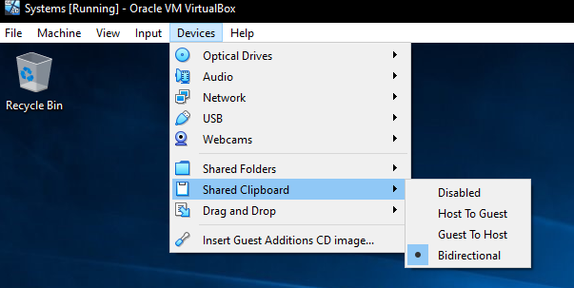

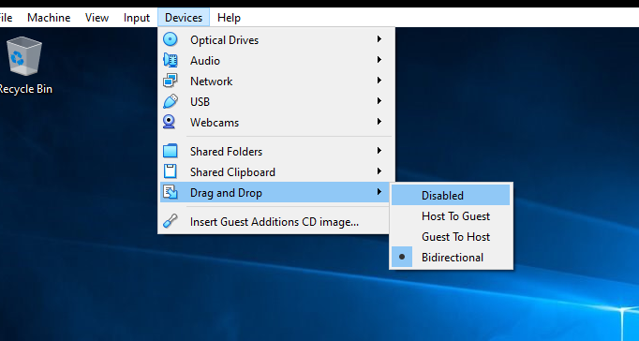

1. Create another 64-bits virtual machine and install Ubuntu 16.04. The virtual machine must meet the following requirements:

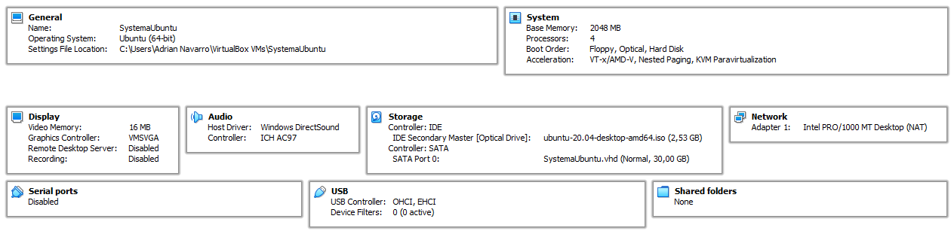

* + 2 GB of RAM memory.
  + Just one disk of 30 GB.
  + A shared folder to an external disk.

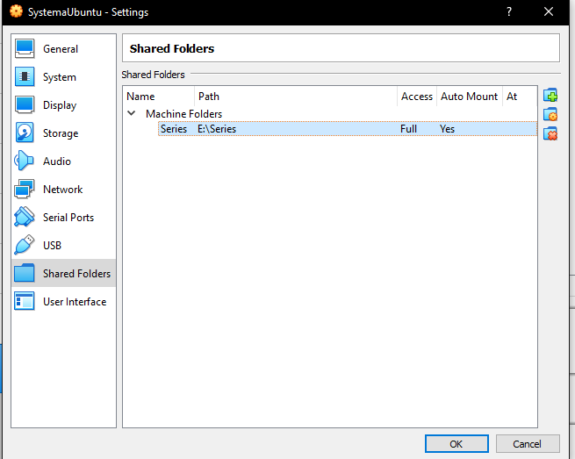

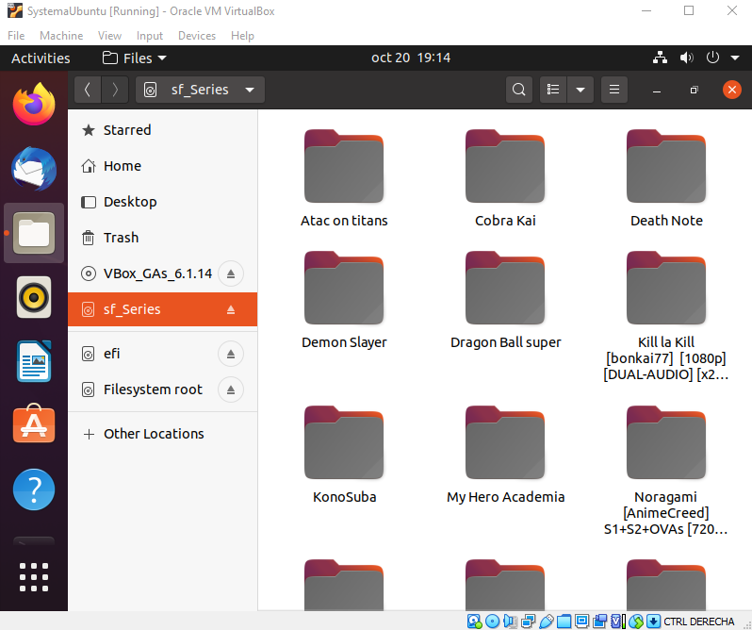

* + Internet connection.

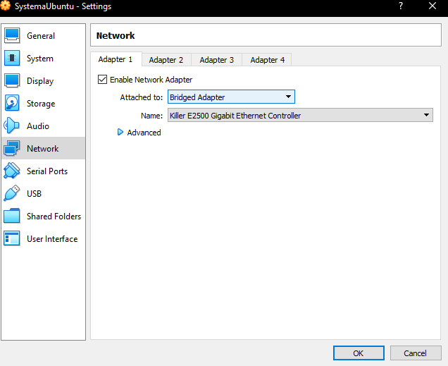

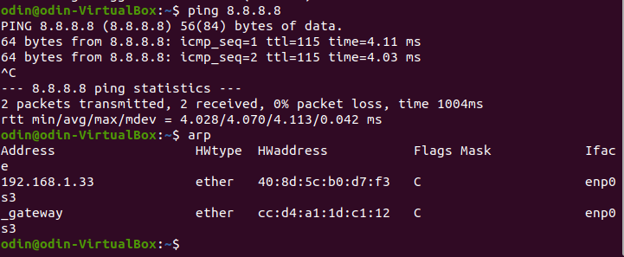

* + You will be able to copy and paste from the host to the guest and vice versa.

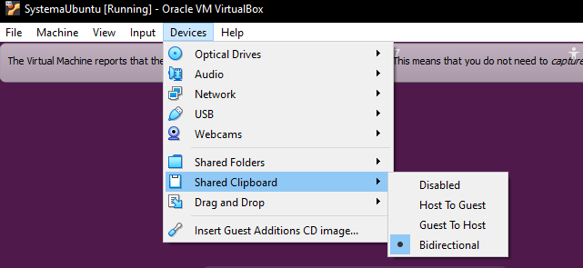

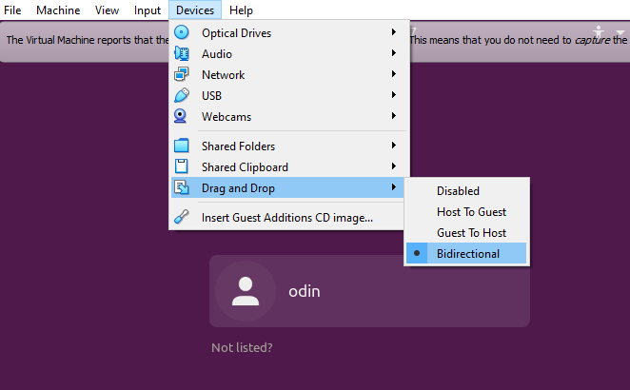

1. Create the snapshots like in the picture below using one of the virtual machines created in the previous exercises. Before each snapshot, you must change something in the operating system. This tool is normally used when performing a critical action or installing software. But, in this case, you can do something so easy as creating a new file to study the different states.

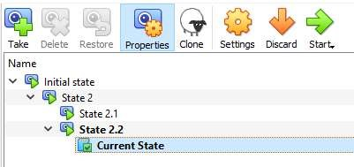

Then, complete the following actions in order:

* + Restore State 2
  + Delete State 2.1 and explain what happens • Restore State 2.2
  + Delete State 2.2 and explain what happens

1